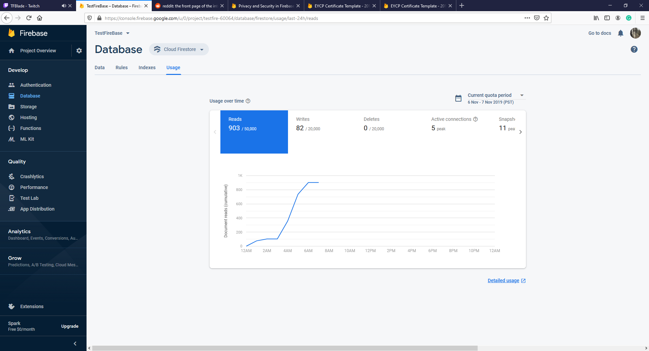

Significant amount of refreshes on data whilst testing changes, highlights issue for abuse with refreshing browsers, consider forcing cache.